Classic City Award Winners from the Trial Gardens at UGA – 2020
Dr. John M. Ruter, Director, and Brandon Coker, Garden Manager

Begonia Double Up™ ‘White’ Proven Winners
Caladium ‘Snow Flurry’ Classic Caladiums
Calibrachoa Colibri™ ‘Malibu Pink’ Danziger
Calibrachoa Cha-Cha™ ‘Diva Apricot’ Ball FloraPlant
Catharanthus Soiree Kawaii® ‘White Peppermint’ Suntory
Echinacea Kimset® ‘White’ Terra Nova
Ipomea Sweet Caroline Medusa™ ‘Green’ Proven Winners
Lantana Gem™ ‘Compact Rose Quartz’ Danziger
Petunia ‘Bee’s Knees’ Ball FloraPlant
Rudbeckia ‘Minibeckia Flame’ Garden Choice
Scaevola Surdiva® ‘White Improved’ Suntory
Zinnia Preciosa™ ‘Scarlet’ American Takii

Begonia Double Up™ ‘White’
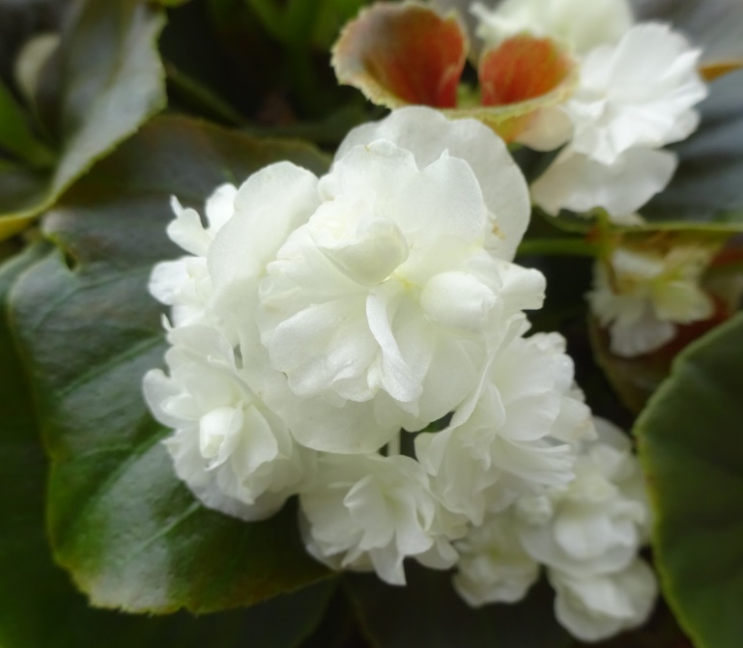
Proven Winners
Begonias run the gamut in terms of how they can be used in the vast ocean of leaves, flowers, and sun/shade tolerances. Double Up™ ‘White’ from Proven Winners only adds the possibilities with its small, double, pure white flowers that continuously bloom against dark green foliage. We have this plant blooming in full sun in the hanging basket and planted in ground. In addition to ‘White’ we are growing Double Up™ ‘Red’ and ‘Pink’. Each is doing well in the garden in particular ‘White’ and ‘Pink’. The begonias in the Double Up™ series are sure to make great additions to containers, hanging baskets, or in ground plantings.
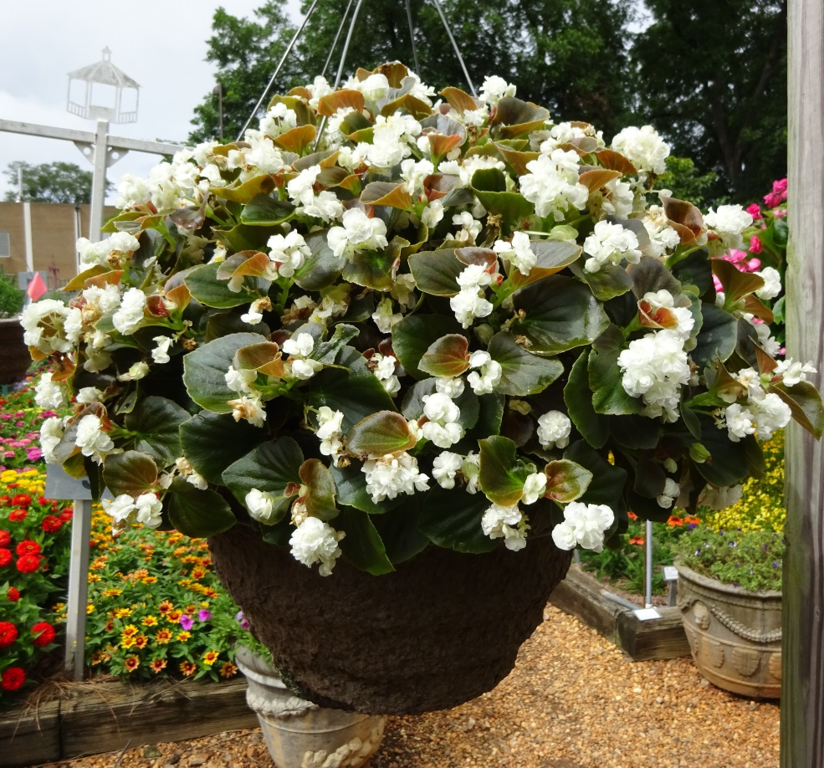

Caladium ‘Snow Flurry’
Classic Caladiums
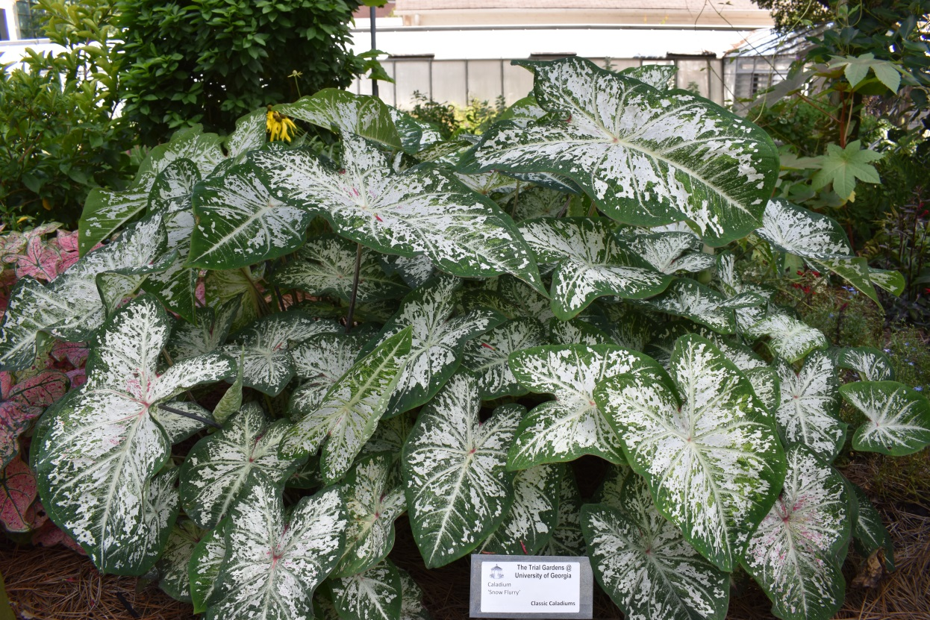
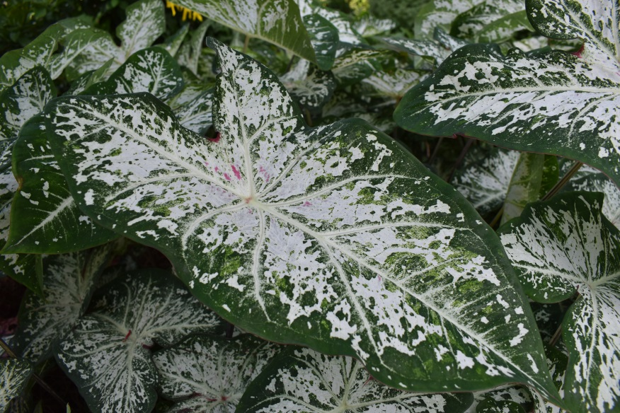
Snow in July? In Georgia? Yep that’s right snow flurrys! ‘Snow Flurry’ Caladium that is from Classic Caladiums is making an impression in the garden both in the ground and in hanging baskets. I have had a major thing for white flowers this year and this beautiful white caladium is worth the time to stop for pictures. The leaves have pure white veins with specks of pink and flow outwards to green margins. ‘Snow Flurry’ is sure to leave a lasting impression at 36+ inches tall with some leaves in excess of 15 inches long – Classic Caladiums has effectively given us summer snow in Georgia.

Calibrachoa Colibri™ ‘Malibu Pink’
Danziger
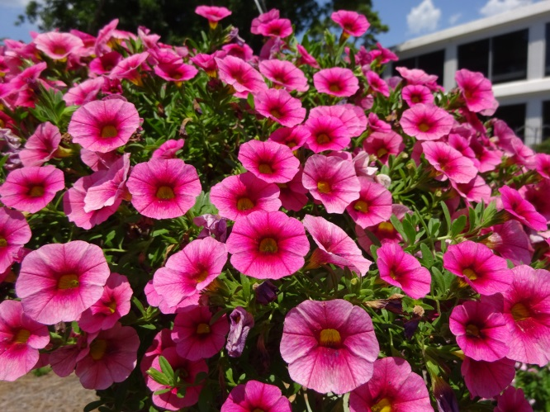
Hot pink flowers are always a hit in the garden. Day after day and week after week Colibri™ ‘Malibu Pink’ have been impressing in the garden with large hot pink flowers with yellow centers. While the plants have not been the largest of the calibrachoas in the garden they have not disappointing with larger than usual flowers that have been so very consistent even during the hottest days. I have enjoyed the more linear growth pattern of the plants per the individual baskets which have resulted in wider baskets with more concentrated flowers.
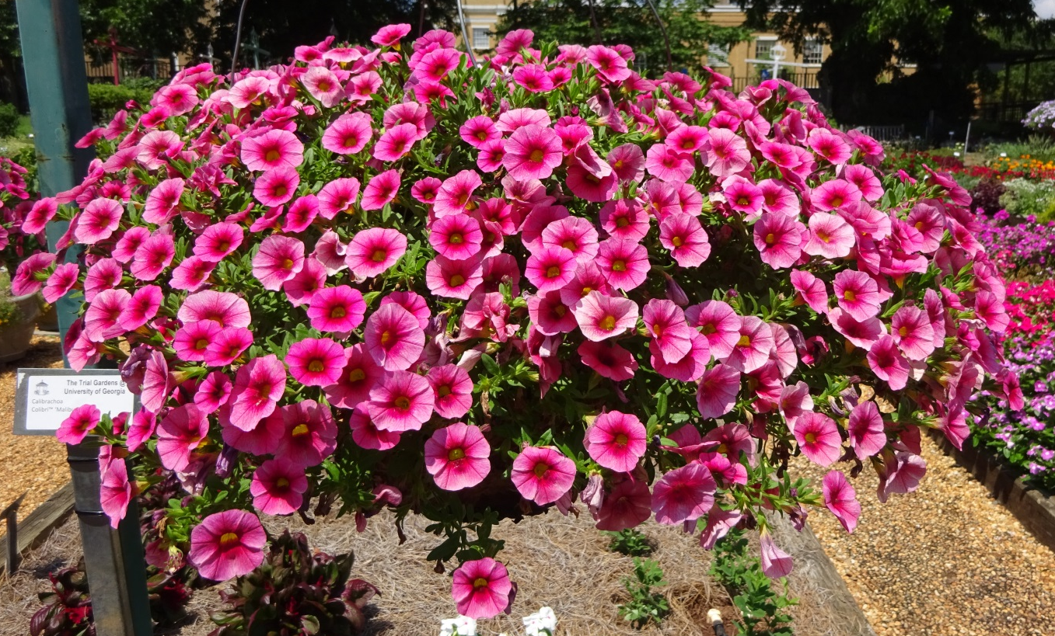

Calibrachoa Cha-Cha™ ‘Diva Apricot’
Ball FloraPlant
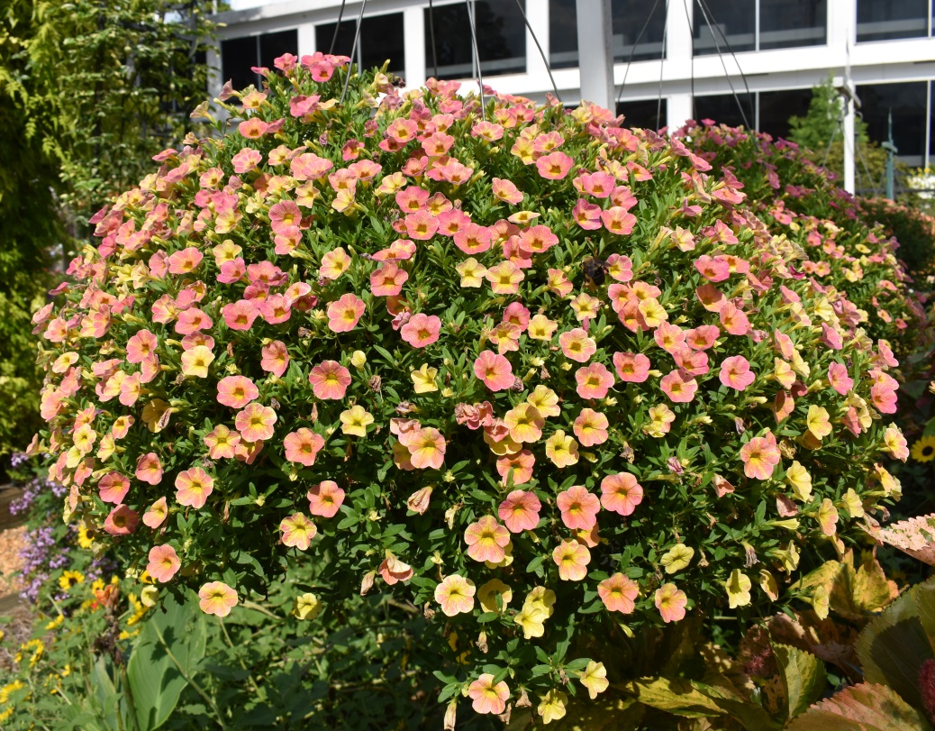
Calibrachoa Cha-Cha™ ‘Diva Apricot’ has been an overall favorite this year from the very beginning when the plants arrived at the greenhouse. Big plants! We plant 4 plants per hanging basket and the ending size of these stunners is 33 inches wide and 21 inches tall. That also says lots of flowers. These yellow and pink flowers remind me of a soft sunset right before the sun rolls over the horizon. Consistency – I have 2 baskets and each look identical which speaks to the overall uniformity of these individual plants because customers look for even planting and growth.

Catharanthus Soiree Kawaii® ‘White Peppermint’
Suntory
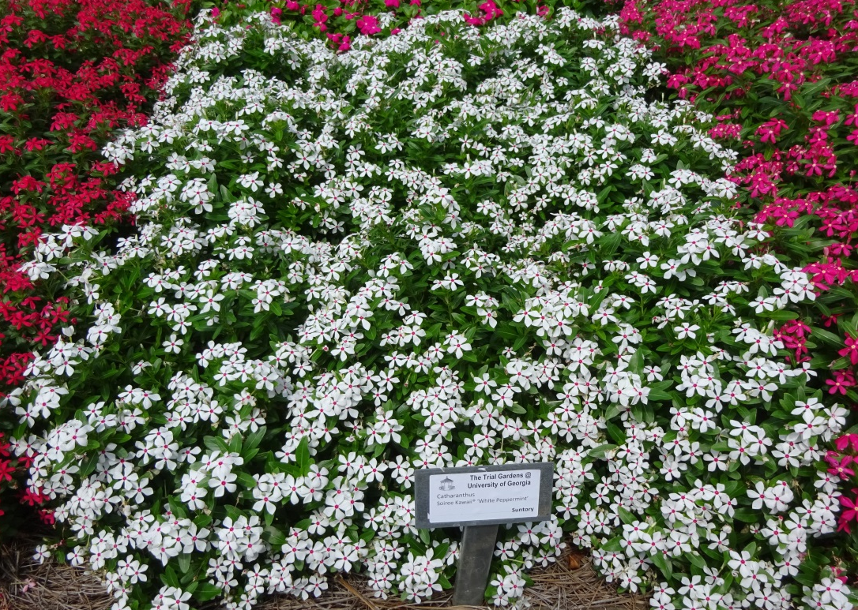
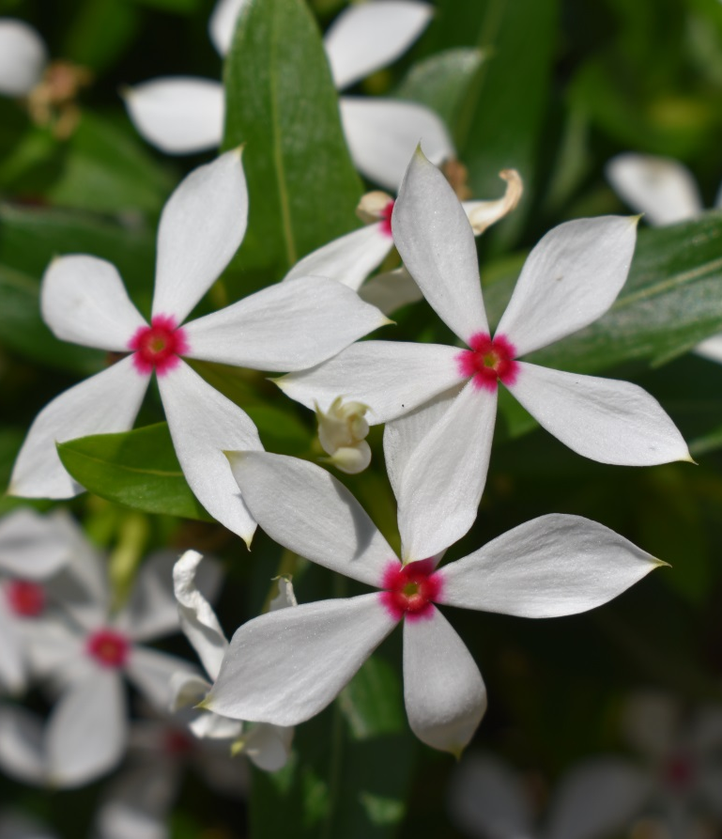
‘White Peppermint’ has been a hit from its arrival to the Trial Gardens here in Athens. It was in bloom then in March and is still blooming in August! That’s something to write home about. This appropriately named cultivar has a candy red ring at the very center of these 5 leaved flowers that are solid white making clusters per branch. At 12 inches tall and with small flowers compared to their larger vinca counterparts (roseus that is) these are every bit as showy because of the mat effect of having so very many self-deadheading flowers open all at one time. We also have ‘Coral’, ‘Coral Reef’ and ‘Red Shades’ all of which are also performing well here in that garden. Not a brand new introduction but one worth investing in.
Echinacea Kimset® ‘White’
Terra Nova
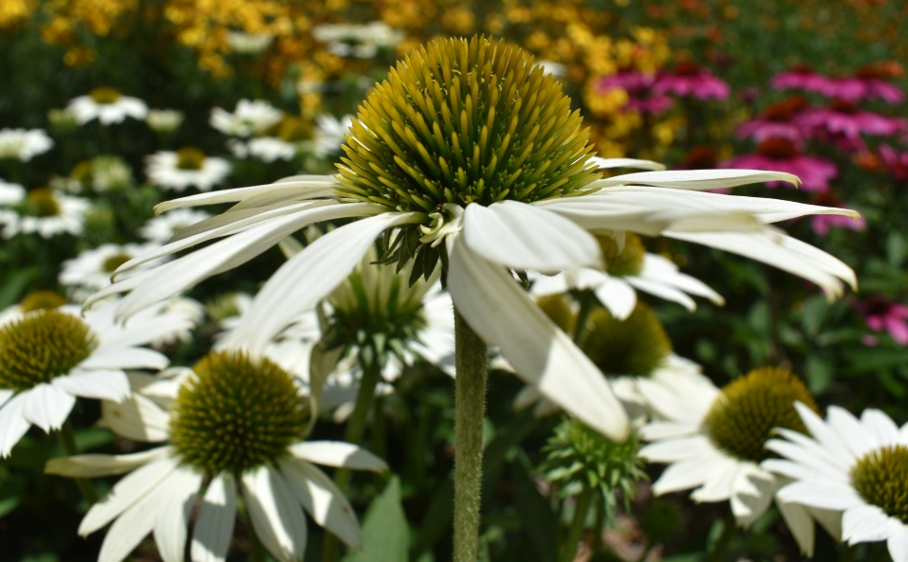
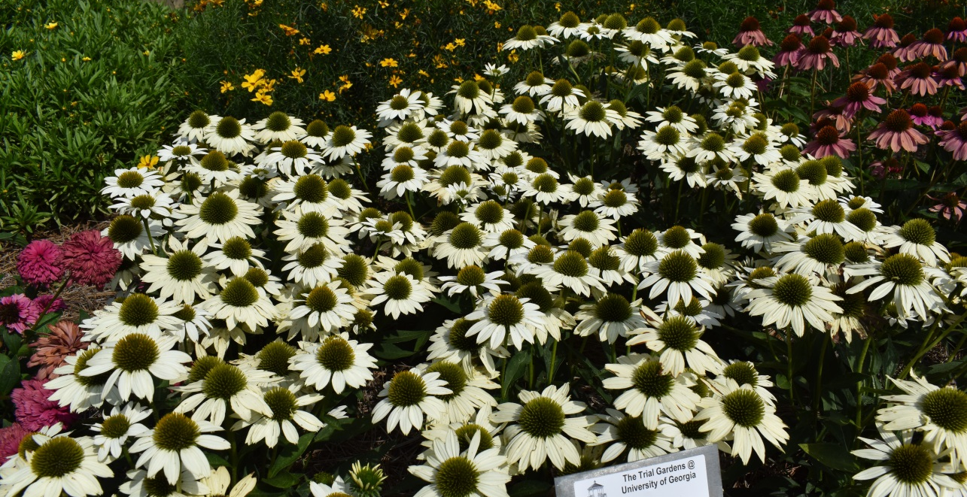
One of the more important factors when selecting plants for the Southeast is that they last the whole season. Investing in plants that don’t last the summer season is not what consumers are interested in. This medium sized Kimset® ‘White’ tics the box on long lasting color. Being the first Echinacea to bloom it intern also was the first cultivar to be in full bloom and to cap off its reign it happens to be outlasting others that started blooming later. Terra Nova has struck a chord with this cone flower and another facet of this cultivar is that the white flowers are fading very well. It’s common for white flowering plants to fade to brown very quick and the longevity of the flower to be short, but these are trending in the other direction by keeping their color and interest longer.

Ipomea Sweet Caroline Medusa™ ‘Green’
Proven Winners
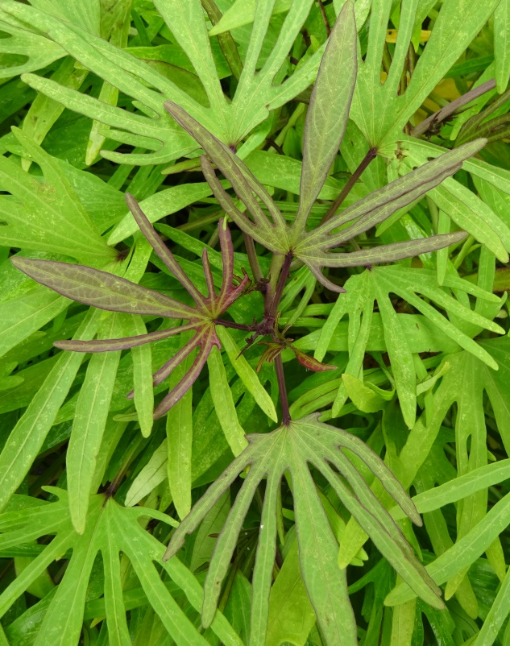
Sweet potato vine is a typical love it or hate it type of landscape plant. I believe you will have a hard time finding people who don’t love Sweet Caroline Medusa™ ‘Green’ from Proven Winners. The finger like leaves is a switch from the typical lobed ipomea that do commonly have lobed leaves but not thin tentacle like leaf spacing. New foliage emerges as a burgundy/green or green with red edging leaves that appear to be reaching out. I thought this would be a dwarf like cultivar at first, but I was wrong; it is a tightly branched compact but large cultivar. We plant these 4 plants to a pot and this cultivar is measuring in excess of 36 inches wide and over 30 inches tall – yes it has our attention!
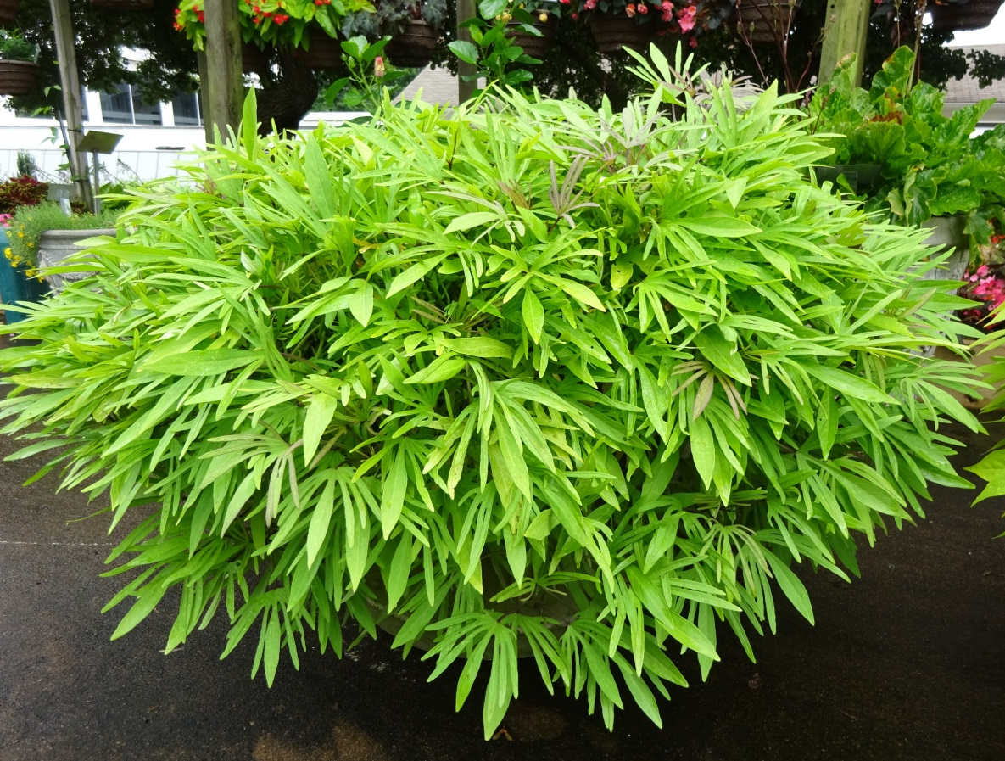

Lantana Gem™ ‘Compact Rose Quartz’
Dummen Orange
This award really goes out to the entire line up of the Gem™ series from Dummen Orange’s annual branch – ‘Compact White Sapphire’, ‘Compact Pink Opal’, ‘Compact Orange Fire’, and our top choice ‘Compact Rose Quartz’. Each of the plants in the trials this year are keeping a excellent compact size at 9 inches tall by 12 inches wide which is perfect for up and coming generations of gardeners. As gardens get smaller, patio gardening, and container gardening gets more and more popular, compact plants that produce flowers through the season will become the go to for everybody and in particular new gardeners. Another important trait for this series is that the flowers are doing a good job at staying above the foliage line which tends to hide flowers in many lantana cultivars.
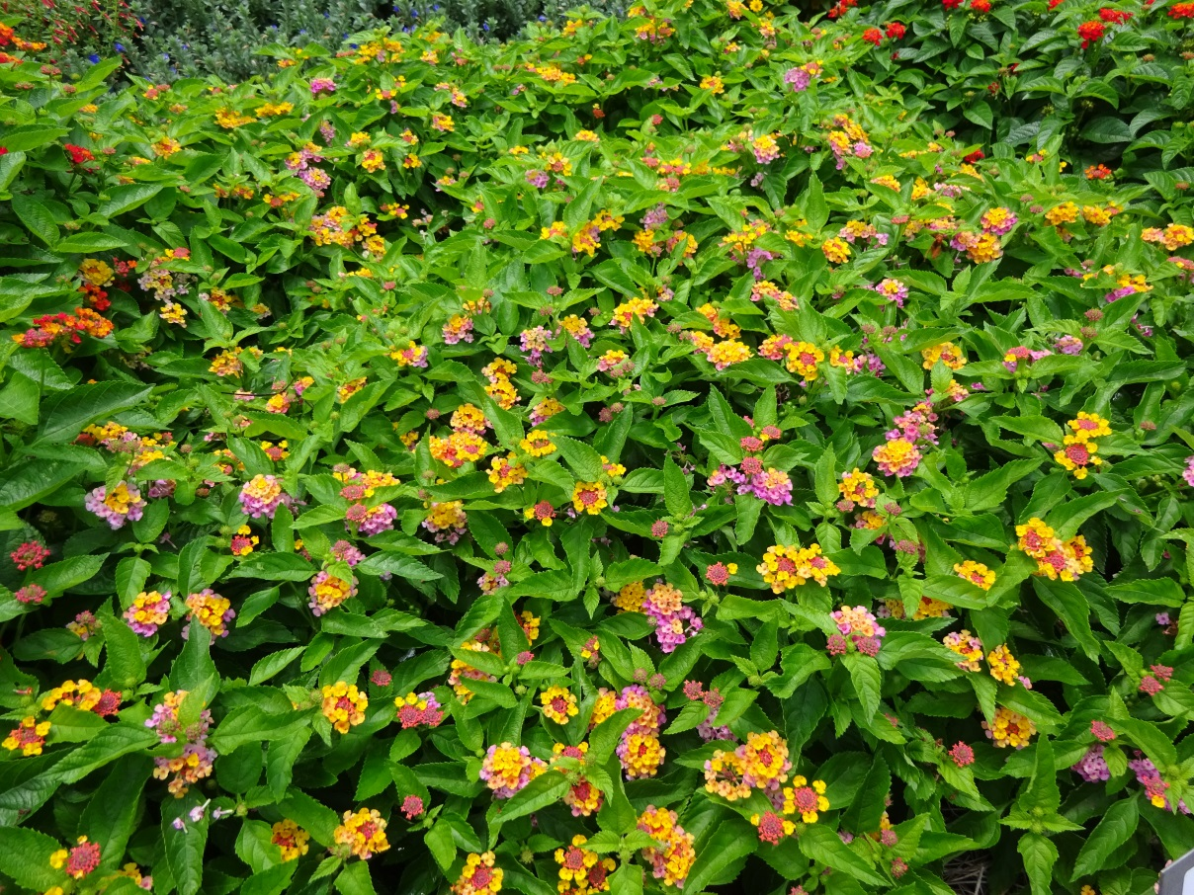

Rudbeckia ‘Minibeckia Flame’
Garden Choice
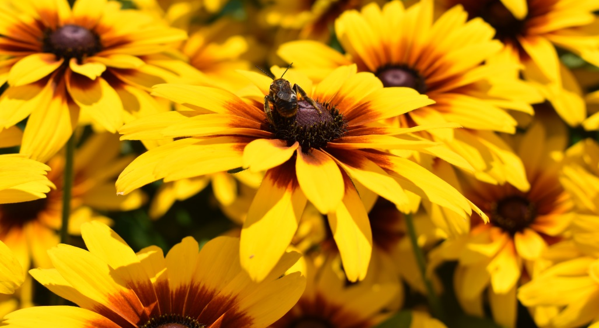
A new comer to the Trial Gardens this year is Garden Choice and they have delivered one of the biggest pops in the garden for 2020. Rudbeckia ‘Minibeckia Flame’ with ease pulled visitors to the garden over to its plot so that everybody could warm by the ‘flame’. Rudbeckia’s tend to be an annual here in the Southeast so I don’t put this in the perennial category, but I am fine with this as an annual. It has been in bloom for 2 months and is still throwing color around the garden. ‘Minibeckia Flame’ would make a good choice for in particular for boarders or even annual beds.
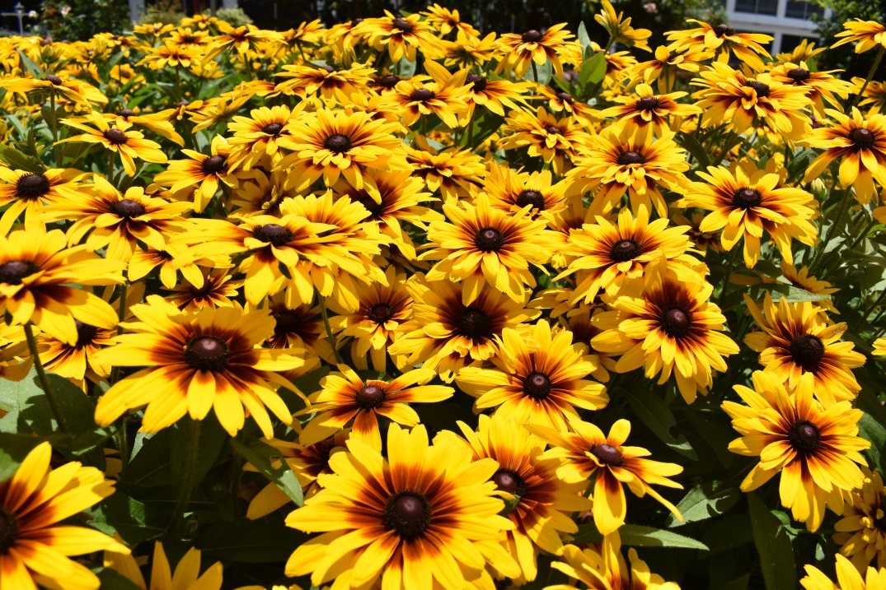

Petunia ‘Bee’s Knees’
Ball FloraPlant
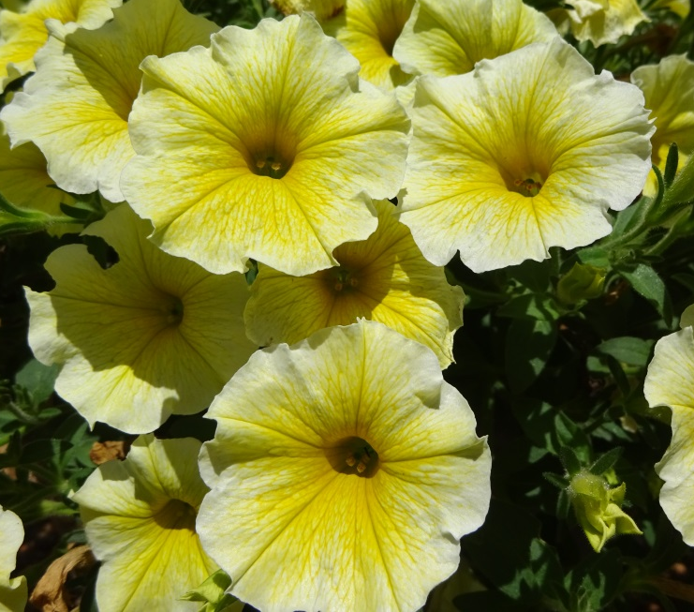
The Petunia ‘Bee’s Knees’ from Ball FloraPlant is an instant hit. Bright yellow flowers that go from deep yellow to pale yellow at the margins serves as an eye catching pop of color that can be used in gardens and landscapes everywhere. The flowers are of typical size with frilly edges which adds to its overall interest. The plants in the pot explode up and out to make perfect mounds of color with healthy green leaves. We love novel colors around here and encourage gardeners to branch out with bold colors which should put ‘Bee’s Knees’ at the top of the list for people looking to out due their neighbors.
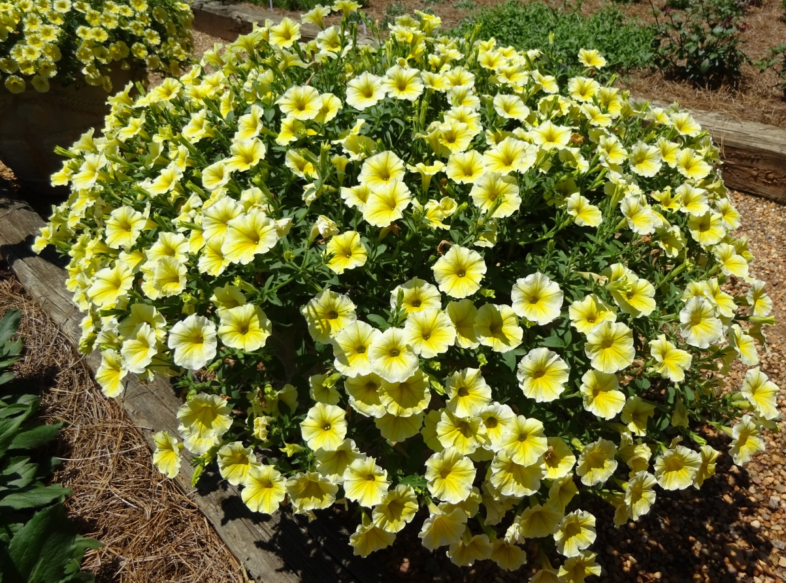

Scaevola Surdiva® ‘White Improved’
Suntory
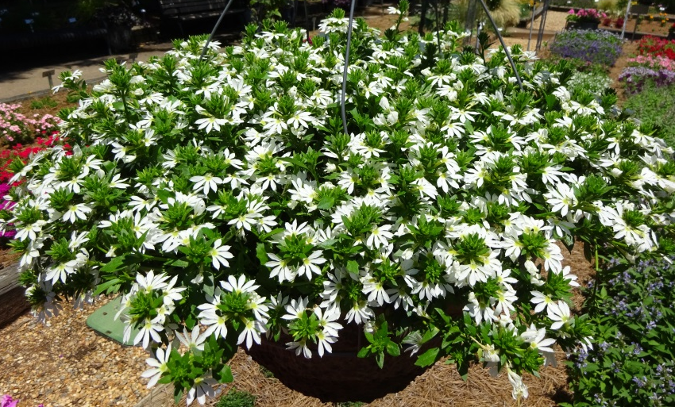
I know what you’re thinking by now, “another white flower for the prestigious University of Georgia Trial Gardens Classic City Awards winners?” Yes indeed. Scaevola Surdiva® ‘White Improved’ from Suntory has earned this honor by showing out in the garden. I knew when these hanging baskets were hung up and 9 plants were planted in the garden that it would be a top cultivar. Graceful fan shaped solid white flowers that have been in bloom all summer have truly been a pleasure to watch just get better and better this year. In addition to just great color it has also stayed compact and has not gotten long in the stem even now in August. Even the in ground planting has out done its rivals by blooming solid blocks of color much like a bit of snow on the ground. In addition to this the other colors in the Surdiva® series have also done well, ‘Fashion Pink’ and ‘Blue Violet’.
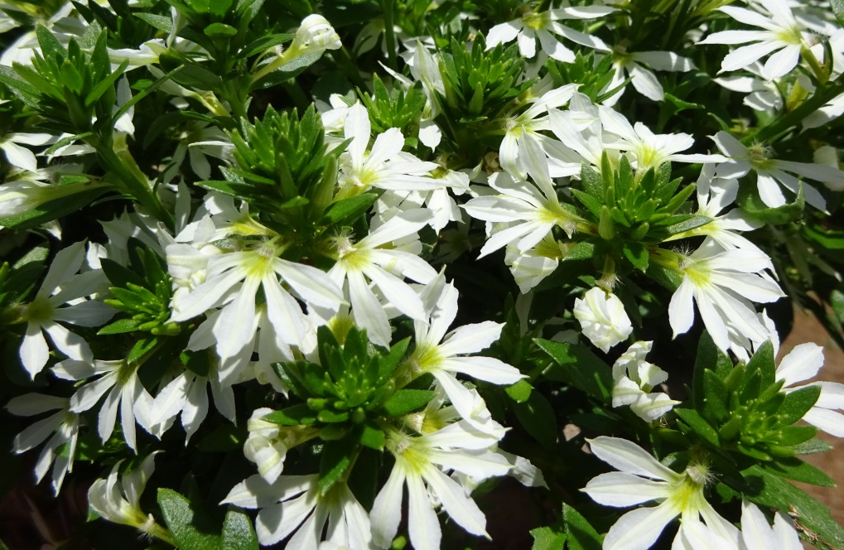
Zinnia Preciosa™ ‘Scarlet’
American Takii
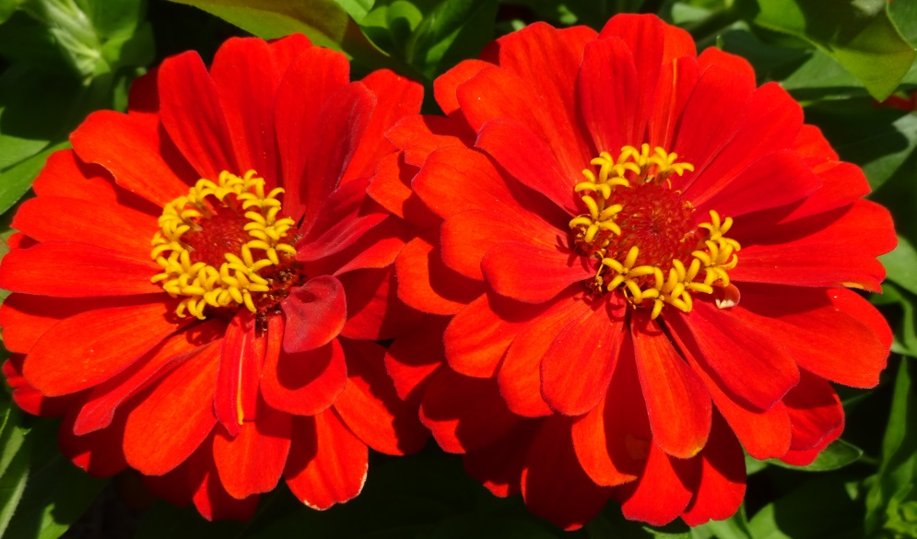
I must admit I personally love zinnia’s, but alas not all zinnia’s are created equal. The Preciosa™ series from American Takii has been most excellent all season long. ‘Scarlet’ out of the bunch has taken the cake in terms of overall bang for the buck. The cultivar has stayed compact with multiple flowers per branch and when old flowers start to fade into the foliage, new flowers are always on the way as this cultivar keeps producing one after another. I know red zinnias are about as common as a leaky hose in the garden, but something is to be said when they stand out amongst the highest level of breeding among bedding plants breed all over the world!
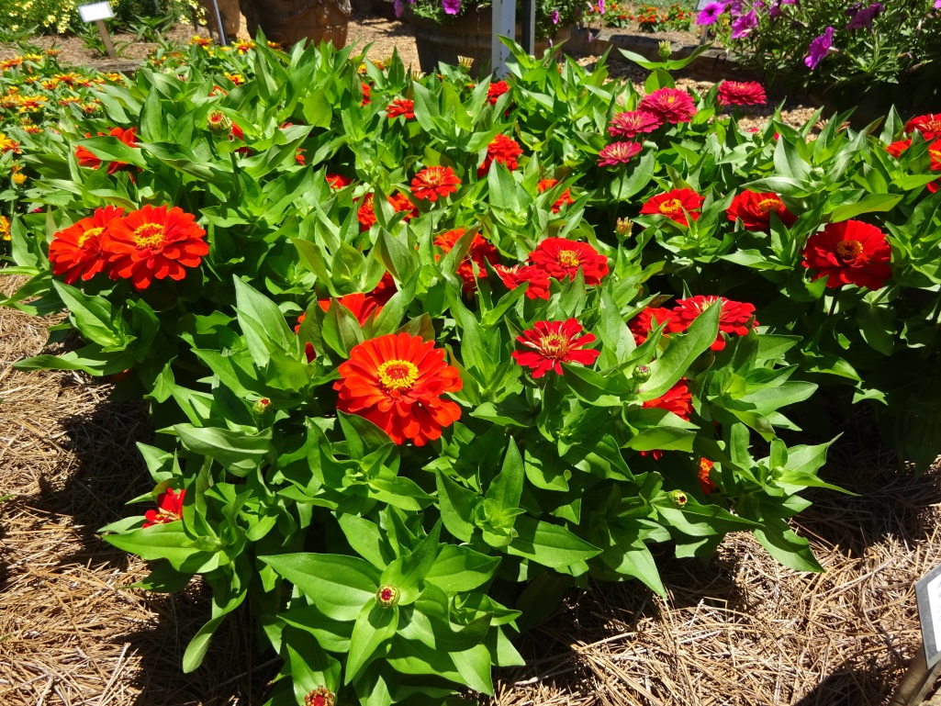
A huge thank you for these excellent companies who trialed with us for the 2020 season!

All America Selections
AmeriSeed
American Takii
Ball FloraPlant
Ball Ingenuity
Classic Caladiums
Danziger Flower Farm
Darwin Perennials
Dummen Orange
European Takii
Evanthia Seeds and Plants
Garden Choice
Intrinsic Perennial Gardens
J. Berry Genetics
Jelitto Perennial Seeds
Must Have Perennials
Pacific Plug & Liner
PanAmerican Seed
Proven Winners
Rijnbeek and Son - Perennials
Suntory
Selecta One
Star Roses
Syngenta Flowers
TerraNova

